# E-Commerce Project (Week 3)

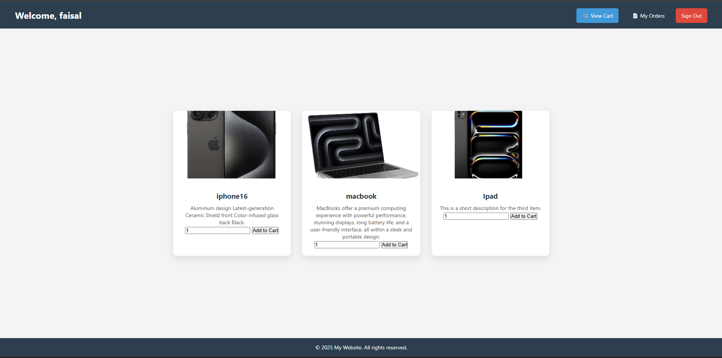

**Developed by: Faisal Alsubaie**

**With consult of: Yura & Islam**

* **Main problems we had:-**

We faced a lot of problems doing the project and a lot of obstacles.

In fact, it would be easier to say what didn’t go wrong so I will focus on the main problems that took more than 2 hours to fix.

1. **Dealing with files,** there are little to none good resources that can help you with dealing with the files.
2. **Templates,** all the templates on the internet require you to pay money.
3. **Validations,** validation wasn’t hard they just took a lot of time to do.

* **How we fixed it:-**

1. We had to try and debug everything until it worked.
2. Asked AI to do the templates.
3. Being patient and doing them one by one.

* **What we learned ?**

The main new things that we learned this week is **Debugging** and handling **Files.**

* **Conclusion**

The task was fun and kept me busy the whole week and improved me a lot to find the problems and solving them.